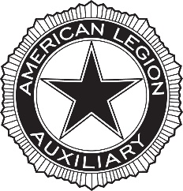
Convention & Events Registration Form
The American Legion National Convention
New Orleans, Louisiana
August 23 -August 29, 2024
Georgia’s Hotel: Hampton Inn & Suites: 1201 Convention Center Blvd., New Orleans, LA. 70130 (504) 566-9990
◊◊◊0◊◊◊◊0◊◊◊◊0◊◊◊◊0◊◊◊◊0◊◊◊◊0◊◊◊◊0◊◊◊

Name:
Address:
City/State/Zip:
E-mail:
Phone: Unit: District:

APPLICABLE FEES
The Auxiliary Secretary is responsible for paying the registration fees for the Department Delegates and Alternates to the Convention.
Guests register through the Auxiliary.
REGISTRATION: $35.00 for each Guests. Must send by July 27, 2024 No Refund
All Delegates, Alternates and Guests must submit this form with this information:
Name:
Membership Id#
Contact Information in case of emergency

Make check payable to ALA Dept of GA $_____________
and ensure it is in the hands of the Department Secretary before July 27, 2024.

Please return this form via mail: Department of Georgia
3035 Mt. Zion Road
Stockbridge, GA 30281
Or FAX: 678-289-8885
DEADLINE FOR ACTION: July 27, 2024

